U-landsforeningen Svalerne – The Swallows

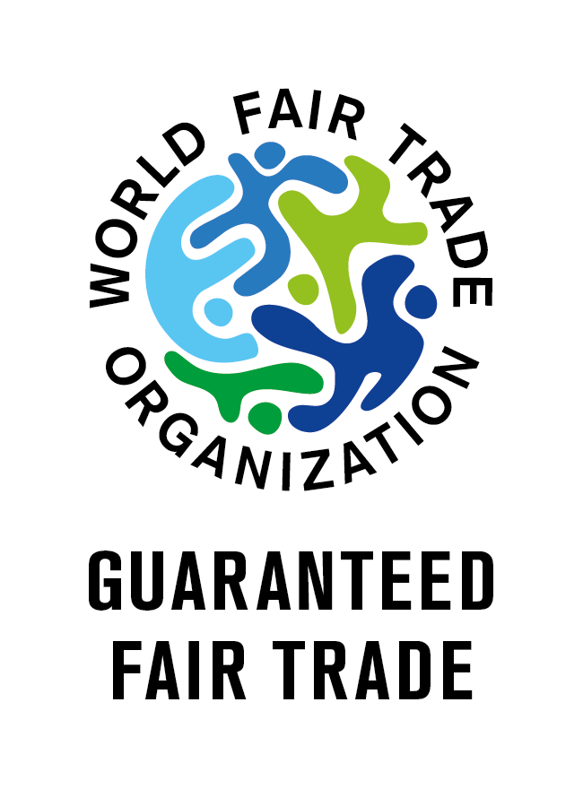



Aarhus Lokalforening

Rosengade 241.o.g.

8000 Aarhus C

Denmark

Tlf. +45 8612 9701

## Annual Report 2023 for Svalerne in Aarhus

In 2022, the Fair Trade Gruppen under Svalerne in Aarhus had a profit of DKK 63,000, which is a satisfactory result. Sales also went well and amounted to a total of DKK 674,000 – an increase of 18% compared to the previous year.

The figure below shows our total imports of Fair Trade products since the beginning in 1975. A smaller part of the imports in recent years has been indirect imports from e.g. El Puente in Germany (including coffee, tea, and earrings), which made up 22% of imports in 2023. Money from the other Fair Trade imports goes *directly* to the poor handicraft producers.

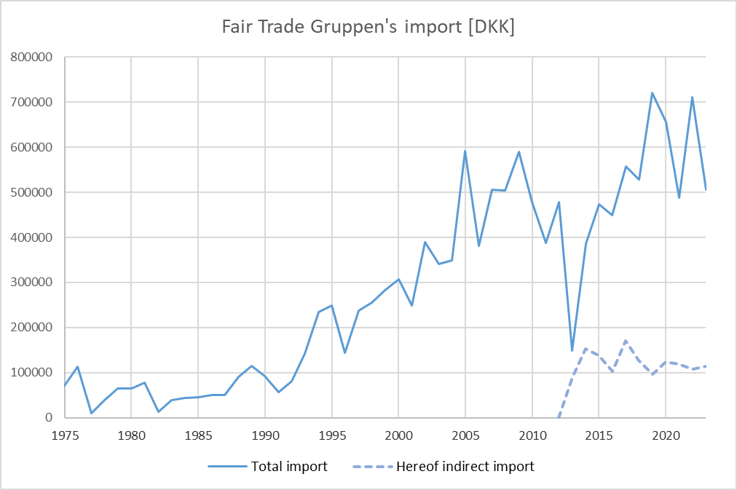

The import is in 2023 distributed among the countries as shown below.

El Puente is in-direct import of coffee and tea via Germany, primary from Tanzania.

The items that sold best in 2023 included: quilted sari rugs, baskets, door mats, purses and bags from Bangladesh, instant coffee from Tanzania, ceramics from Nepal, jewelry from Chile and hammocks from El Salvador. More information can be found on our website: <http://www.fair-trade-gruppen.dk>.

Fair Trade Gruppen is a guaranteed member of the World Fair Trade Organization (WFTO) (<https://wfto.com/>). This helps to guarantee Fair Trade, and all producers we import from are members of the WFTO or belong to the Fair Trade Group's own internal monitoring system, which is approved by the WFTO.

In the autumn, we had a visit from Manfred Winkler from the German Fair Trade importer Globo. We will investigate whether we can arrange joint sea freight of the hammocks from El Salvador with the aim of reducing freight costs. In connection with the visit, we held an event where Manfred talked about Globo's work over 50 years.

During February's visit to the Ambiente fair in Frankfurt, we agreed to start a collaboration with Mitra Bali from Indonesia. Small family workshops on the island sell their handicrafts to local buyers, who sell the goods on to the island's many tourists at a large profit. Mitra Bali was created with the aim of ensuring the artisans a greater share of the value of their work. The first consignment of goods is expected to arrive in Denmark around 1 March, depending on the situation in the Gulf of Aden.

For a few years, we have helped the Fair Trade stores with the import of alpaca socks from Classic Alpaca in Peru. In 2023, we expanded the import with some nice hats and mittens. Some of these goods are included in the Fair Trade Group's own warehouse. We will make much more out of that in 2024.

In the spring, the young members of the local association organized a support sale of small clay figures from Bangladesh at the 1 May event in Aarhus. People welcomed the Swallows, and the rickshaw they brought with them worked well as an eye-catcher. Some of the children were lucky enough to get a ride on it, and we received approx. DKK 2,000 in support to the Svalerne. At the same time, there was advertising for an event at Cafe Mellemfolk in May with focus on working conditions. Here, Lis and Marie came over from Copenhagen and gave two exciting talks, with subsequent debate and questions. Despite the relatively few participants (13 in total), it was a successful evening.

Thanks to the members of the association for their support and to the volunteers who help in the various Fair Trade activities in which U-landsforeningen Svalerne in Aarhus has been involved.

*Greetings from Aarhus - Poul and Thomas*

U-landsforeningen Svalerne – The Swallows





Aarhus Lokalforening

Rosengade 241.o.g.

8000 Aarhus C

Denmark

Tlf. +45 8612 9701

## Annual Report 2022 for Svalerne in Aarhus

In 2022, the Fair Trade Gruppen under Svalerne in Aarhus had a profit of DKK 1,100. The smallest profit for many years. This is not least due to the extremely high freight rates for container transport - the price of a container from Bangladesh has risen from DKK 12,000 to DKK 76,000 - but also due to the high dollar exchange rate. We did not let these - hopefully temporary - extra costs fully affect the sales prices.

Sales in 2022 amounted to DKK 572,000 - a decrease of 10%. This is due, among other things, to closure of two of our best customers and otherwise natural year-to-year fluctuations.

The figure below shows our total import of Fair Trade products since the start in 1975. A small part of the import in recent years have been indirect import from among others El Puente in Germany (coffee and tea), which accounted for 15% of the import in 2022. Money from the other Fair Trade imports directly benefit the poor artisan producers.

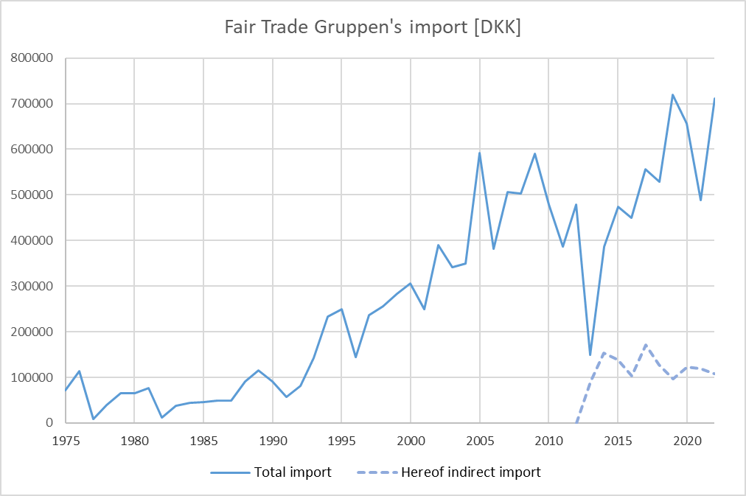

The import is in 2022 distributed among the countries as shown below.

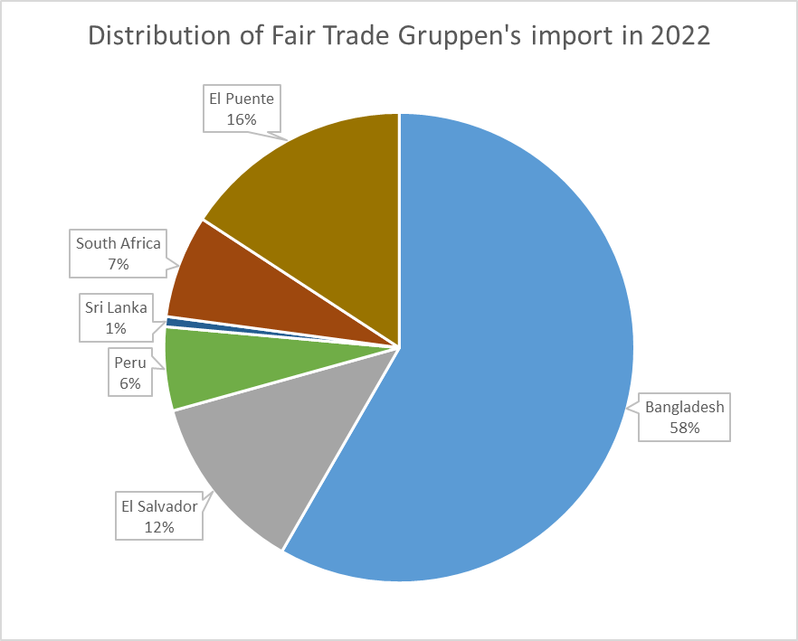

El Puente is in-direct import of coffee and tea via Germany, primary from Tanzania.

The best-selling items in 2022 were: quilted sari rugs from Bangladesh, baskets from Bangladesh, door mats from Bangladesh, instant coffee from Tanzania, cradles from Bangladesh, and silk scarves from Bangladesh. More information can be found on our website: <http://www.fair-trade-gruppen.dk>.

Fair Trade Gruppen is a guaranteed member of the World Fair Trade Organization (WFTO) (<https://wfto.com/>). This helps to guarantee Fair Trade, and all producers we import from are members of the WFTO, except for Exporsal in El Salvador, which therefore falls under Fair Trade Gruppen's own internal monitoring system (IMS). In this connection, IMOcert Latinoamerica's auditors have carried out a control visit to Exporsal on our behalf in 2022. Their report concludes that Exporsal meets all WFTO requirements. IMOcert is based in Bolivia and has almost 20 years of experience with a wide range of certification tasks. WFTO recognizes and recommends them as auditors.

On behalf of Fair Trade Gruppen, Poul has participated in the WFTO world meeting in Berlin, where he, among other things, met a representative of People Tree in Japan who recently visited The Swallows in India, which People Tree Japan supports with new designs and sales. The Swallows in Thanapara also participated in the world meeting.

At the end of the year, Fair Trade Gruppen was able to boost concrete cooperation between a number of social entrepreneurs in Central Jutland. We have now joined forces on a gift package project, where in autumn 2023 we will sell social Christmas gift packages to businesses and institutions in Central Jutland.

A collaboration between WFTO and SEWF (Social Enterprise World Forum) means that Svalerne in Aarhus is now also certified by SEWF.

Thanks to the members of the association for their support and to the volunteers who help in the various Fair Trade activities in which U-landsforeningen Svalerne in Aarhus has been involved.

*Greetings from Aarhus - Poul and Thomas*

U-landsforeningen Svalerne – The Swallows





Aarhus Lokalforening

Rosengade 241.o.g.

8000 Aarhus C

Denmark

Tlf. +45 8612 9701

## Annual Report 2021 for Svalerne in Aarhus

2021 was a good year for the Fair Trade Gruppen with a turnover of approx. DKK 640,000 (ex VAT) against DKK 540,000 in 2020 and DKK 625,000 in 2019. In 2021, we transferred / paid DKK 490,000 to the producers as payment for the imported goods. The profit was approx. DKK 92,000, and we are in the process of ordering new items for the money.

The figure below shows our total import of Fair Trade products since the start in 1975. A small part of the import in recent years have been indirect import from among others El Puente in Germany (coffee and tea), which accounted for 24% of the import in 2021. Money from the other Fair Trade imports directly benefit the poor artisan producers.

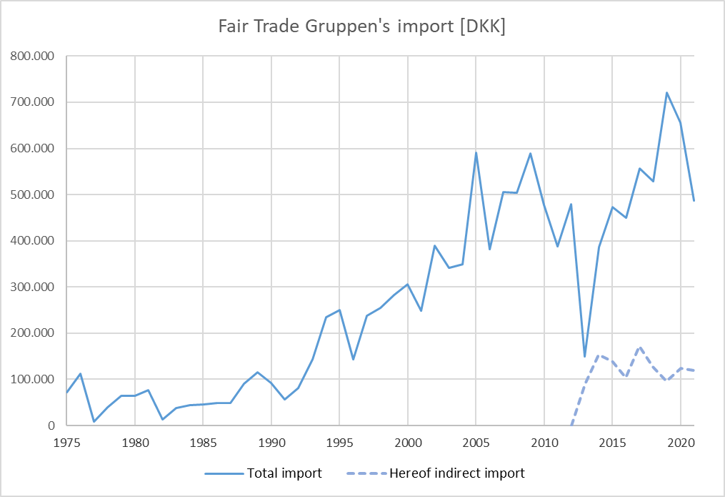

The import is in 2021 distributed among the countries as shown below.

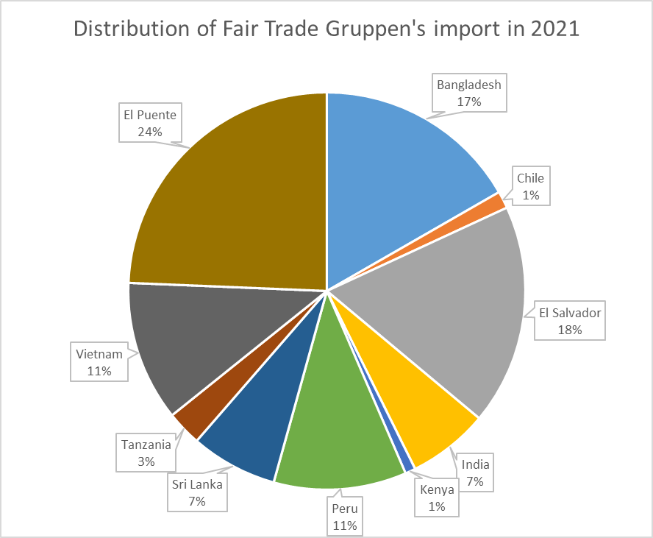

El Puente is in-direct import of coffee and tea via Germany, primary from Tanzania.

More information – e.g., regarding which products sells most - can be found on our website: <http://www.fair-trade-gruppen.dk>.

Fair Trade Gruppen is a guaranteed member of World Fair Trade Organization (<https://wfto.com/>) and in 2021 we got our updated Self-Assessment Report and peer review approved by WFTO. This helps to guarantee that we are trading Fair Trade.

Our Fair Trade store in Holstebro has also had a good year with a sales increase of 20%. The turnover of DKK 211,000 is the best since 2012. The profit here was almost DKK 16,000.

After the Ambiente trade fair in Frankfurt has been canceled for two years in a row, we look forward to seeing many new products from the producers at the WFTO's world meeting in Berlin in August. As corona shutdowns have hit the producers hard, many of them are having a hard time financing the trip to Berlin. We have therefore donated € 1,000 in support to the WFTO's fundraiser to finance producers' participation in the Berlin Summit. It is also a good investment, as in this way we will get access to see many new products. It is thus a win-win aid.

Despite the corona crisis and the closure of the store in the first two months of the year, things are going well in the Fair Trade Bazaren shop in Aarhus, where sale decreased by only 1% compared to the previous year. There have been sales for DKK 1.7 million (incl. VAT) here and the profit for the year was approx. 40,000 kr.

During the year, we have a new registered public accountant, and at two extraordinary general meetings at the end of 2021, we have had our articles of association amended so that an audit of the accounts is no longer required, but only an auditor's statement of assistance. It can save us a lot of accounting expenses.

In November, we had a successful event at Fairbar on Klostertorv, where - among others – there was information about the Swallows' partners in the south. The great film about raising awareness of women through song and dance at SOVA in West Bengal was shown, and there was talk of debate competitions in schools organized by Net to Rights in Bangladesh, where very young people debate about women's rights and the violence, they become exposed to both physically, mentally and financially. 20-25 people came to the event, and there were many good questions from an active audience. Thanks to Lis, Marie, Janice, who had taken the trip from Copenhagen to tell, and to Ane and Rebecca, who arranged the event in Aarhus.

In October, we had a visit from Eva, who on behalf of the association of Swedish Fair Trade shops has visited Gospel House in Sri Lanka, which she told about at an event in the meeting room in Rosensgade.

Grethe has sold things from Bangladesh in a Christmas sales booth and had many good talks with the customers with information about Bangladesh. The profits from this go to Parul and Shahid's projects in Bangladesh.

Thanks to the members of the association for their support and to the volunteers who help in the various Fair Trade activities in which U-landsforeningen Svalerne in Aarhus has been involved.

*Greetings from Aarhus - Poul and Thomas*

U-landsforeningen Svalerne – The Swallows





Aarhus Lokalforening

Rosengade 241.o.g.

8000 Aarhus C

Denmark

Tlf. +45 8612 9701

## Annual Report 2020 for Svalerne in Aarhus (Fair Trade Gruppen)

As for so many others, 2020 was marked by the corona epidemic which coursed a huge decrease of the sale in many shops – also shops who sell Fair Trade products.

Despite this, Fair Trade Gruppen imported for DKK 656,000 (ex VAT) in 2020 – though a 9% decrease compared to the year before. The import will directly benefit the poor handicraft producers, but these have also been hard afflicted by corona in 2020. Furthermore, we have paid DKK 161,000 in advance for items from Bangladesh, India, Sri Lanka, Zanzibar, and South Africa. Since the shops have been forced to close, the stock is full and more products are on the way, so we hope the lost can be gained again when we pass the corona crisis.

The sale of goods was decreased by 14% to DKK 540,000 (ex VAT) and the result was a profit of DKK 58,000 (in 2019 it was DKK 82,000).

The figure below shows our total imports of Fair-Trade products since our start in 1975. A minor part of the import has recent years been in-direct import from (among others) El Puente in Germany who share 19% of the import in 2020.

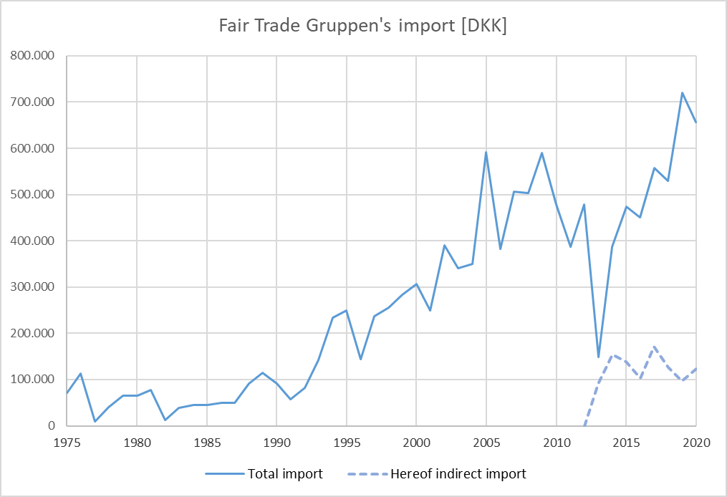

The import is distributed among the countries as shown below.

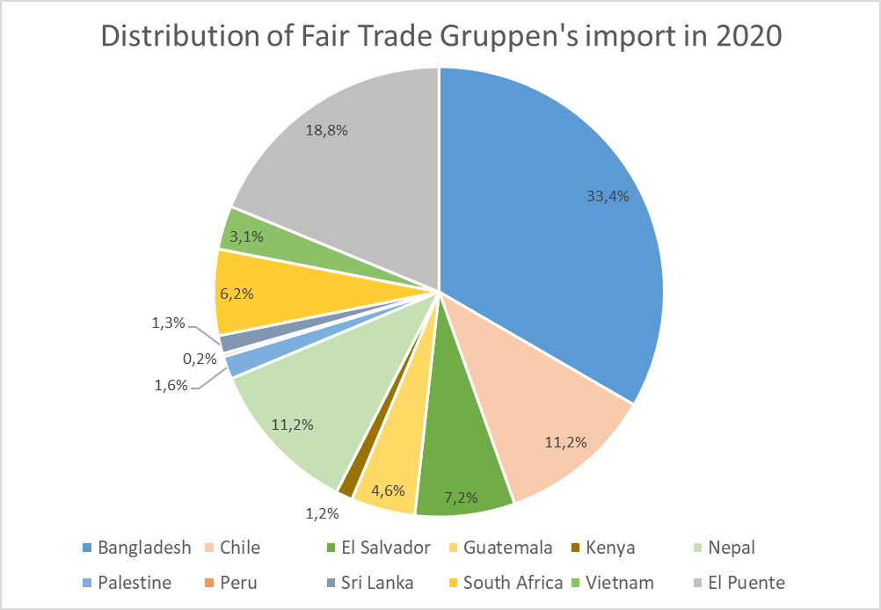

El Puente is in-direct import of coffee and tea via Germany, primary from Tanzania.

More information – e.g., regarding which products sells most - can be found on our website: <http://www.fair-trade-gruppen.dk>.

Fair Trade Gruppen is a guaranteed member of WFTO (<https://wfto.com/>) and we work currently on our second edition of the Self-Assessment Report, which should be approved and secure that also we trade Fair-Trade.

All things considered it goes well for the shop Fair Trade Bazaren in Aarhus where the sale is increased by 2% compared to the previous year. In 2020, the sale was DKK 1.7m (including VAT) and a profit of nearly DKK 40,000 is expected (in 2019 it was DKK 84,000). 88% of the sale in the shop is certified either by WFTO or by FLOI.

During 2020, Poul visited The Ambiente Fair in Frankfurt together with people from Bazaren where they met with many of our Fair-Trade suppliers just before the corona shuts down Europe.

Thanks to the members of the association for their support and to the volunteers who help in the various Fair-Trade activities in which U-landsforeningen Svalerne in Aarhus has been involved.

*Greetings from Aarhus - Poul and Thomas*

U-landsforeningen Svalerne – The Swallows





Aarhus Lokalforening

Rosengade 241.o.g.

DK-8000 Aarhus C

Denmark

Tlf. +45 8612 9701

## Annual Report 2019 for Svalerne in Aarhus (Fair Trade Gruppen)

2019 was again a good year for the import section, Fair Trade Gruppen. The sale of goods is increased by 8 % to DKK 627,000 (ex VAT) and the final result was a profit of DKK 82,000.

The figure below shows our total imports of Fair-Trade products since our start in 1975. A minor part of the import has recent years been in-direct import from (among others) El Puente in Germany who share 13% of the total import in 2019.

As seen, the import has never been larger for Fair Trade Gruppen than in 2019. The money from Fair Trade import will benefit directly the poor handicraft producers.

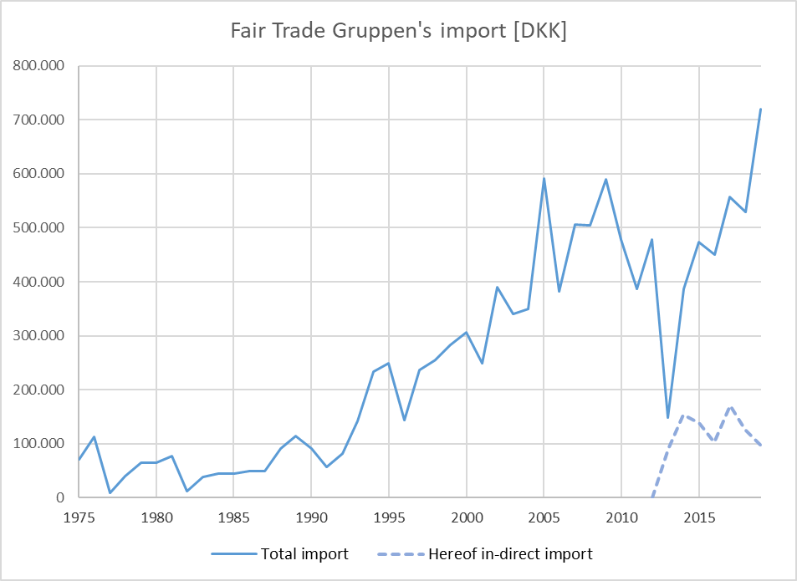

In 2019 Fair Trade Gruppen imported for DKK 720,095 – an increase on 36% compared with the previous year. The import is distributed among the countries as shown below.

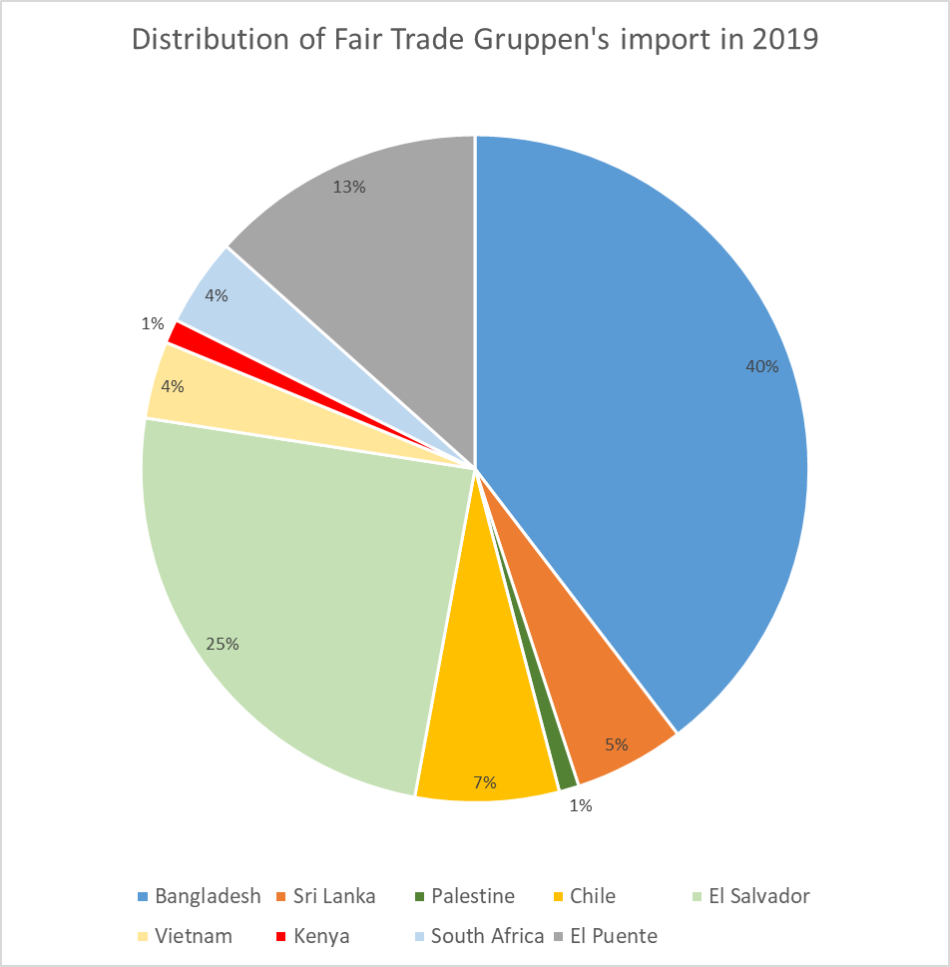

El Puente is in-direct import of coffee and tea via Germany, primary from Tanzania.

More information – e.g. regarding which products sells most - can be found on our website: <http://www.fair-trade-gruppen.dk>.

Fair Trade Gruppen has in 2019 become a guaranteed member of WFTO (World Fair Trade Organization, <https://wfto.com/>), after a longer acceptance period with filling out Self-Assessment Report and Monitoring Audit. We are very satisfied and proud of this, since WFTO worldwide is setting standards for what is real Fair Trade. Being a member of WFTO is an ongoing process where demands for improvements continuously are stated. So, we cannot just lay back and rest in satisfaction. In the moment we are working on lists to secure that the imported handicrafts are okay regarding environmental impact. In June, Poul participated in the yearly meeting in WFTO Europe in Brussels.

It is also good at the shop Fair Trade Bazaren in Aarhus, where sales have increased 4% compared to last year. They have sold for DKK 1.66m (including VAT).

During 2019, Poul visited The Ambiente Fair in Frankfurt together with people from Bazaren and the Fair-Trade Svalerne shop in Copenhagen. They met with many of our Fair-Trade suppliers.

Some young members of Swallows (Svalerne) sold small clay elephants and tortoises at the 1st of May arrangement in Aarhus to a price people could decide by themselves. At the same time, they handed out pamphlets and told about our work. It was a success and all 80 clay animals were sold. The surplus on nearly DKK 3000 went to the Swallow’s work in India and Bangladesh.

In December, Marie, Sarah, and our coordinator, Sanne, visited us for a successful arrangement where Marie and Sarah’s exciting short film from SOVA in West Bengal was shown. It is about how SOVA - a partner organization of Swallows – are using songs and dances in their work with some of India’s poorest women.

Finally, we would like to thank the members of the association for their support and to the many volunteers who help in the various Fair-Trade activities in which U-landsforeningen Svalerne in Aarhus has been involved.

*Greetings from Aarhus - Poul and Thomas*

Holstebro Fair-Trade shop

It has been a good year for Fair Trade Holstebro. After a decreasing sale it luckily wise went the other way two years ago and last year we exceeded DKK 200,000. Perhaps not that much for a larger shop, but we are satisfied.

At the moment we are 10 volunteers. Only one man, and you are young if you haven’t passed 60. It goes well with taking care of the shop since we’re very stable.

Our facade has been renovated with a new door and window and we have a new hanging sign on which it is shown that we are a part of Svalerne (The Swallows)

We hope you will visit us, if you’re going to a trip to the West Coast.

*Greetings from Holstebro – Hanne*

U-landsforeningen Svalerne



Aarhus Lokalforening

Rosengade 241.o.g.

DK-8000 Aarhus C

Denmark

Phone +45 86 12 97 01

## Annual Report 2018 for Svalerne in Aarhus (Fair Trade Gruppen)

2018 has been a good year for Fair Trade Gruppen. The sale of goods is increased by 12% to a total of DKK 581,000 (ex VAT) and the final result was a profit of approx. DKK 40,000.

The figure below shows our total imports of Fair Trade products since 2012. This is inclusive in-direct import from El Puente in Germany and Fair Forward in Holland. The money from Fair Trade import will benefit directly the poor handicraft producers.

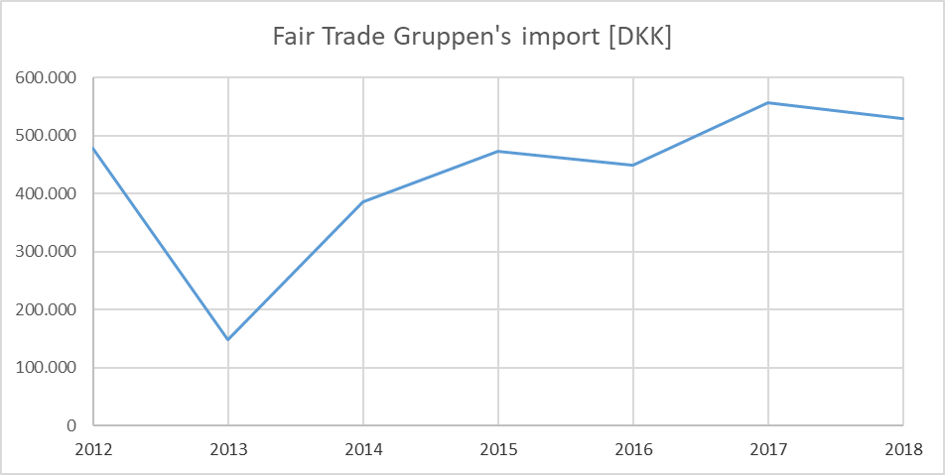

In 2018 Fair Trade Gruppen imported for DKK 528,757 – a decrease of 5% compared with the previous year. The direct import from 3rd world countries was increased with 4%, though. The import is distributed among the countries as shown below.

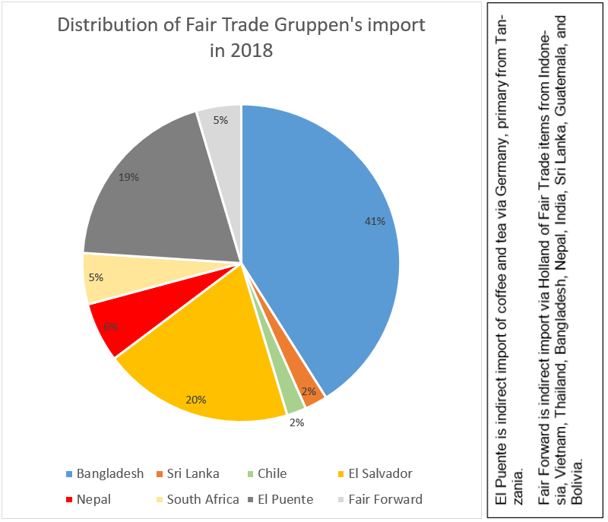

The 25 items that Fair Trade Gruppen sells most are shown in the figure below, where you can see how much the individual product groups make up of the top 25 sales.

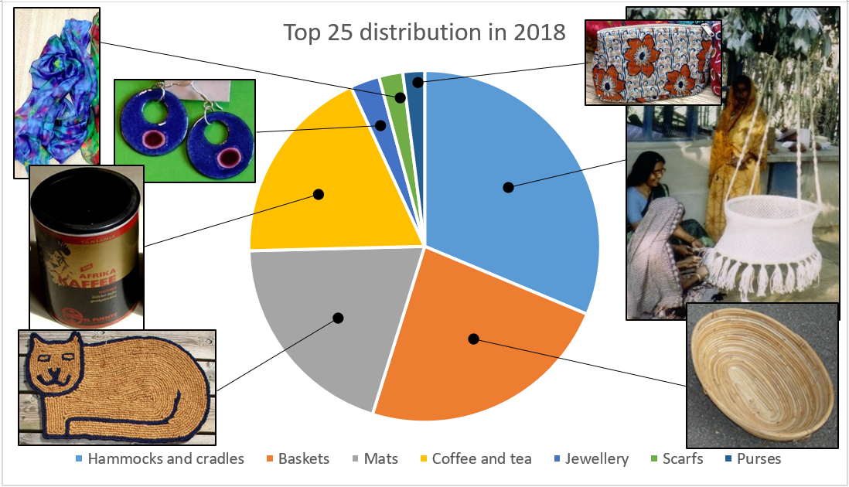

For the most we sell hammocks, baskets, mats, and coffee. More information can be found on our website: <http://www.fair-trade-gruppen.dk>.

Fair Trade Gruppen is provisional member of WFTO (World Fair Trade Organization) but after filling out a Self Assessment Report and a successful Monitoring Audit, we expect soon to become a full member.

The shop Fair Trade Holstebro has sold for DKK 179,000 DKK (including VAT) – an increase of 19% and we expect a little profit in 2018.

It is also good at the Fair Trade Bazaren in Aarhus, where sales have increased 16% compared to last year. They have sold for more than DKK 1.6m – in December alone the sale was approx. DKK 325,000 (including VAT).

During 2017, our Fair Trade shop in Holstebro had a public summer event 1st of June where singers from Odinskolen and small ensembles from Orkesterefterskolen contributed to attract people. In February Poul – together with three persons from Bazaren and two from the Fair Trade shop in Vejle – visited the Ambiente Fair in Frankfurt where they met many of our Fair Trade suppliers from Bangladesh, Sri Lanka, El Salvador and more countries. This resulted among others in a new supplier to Fair Trade Gruppen: Craft Link from Vietnam. In June, Poul participated in WFTO Europe’s yearly meeting in Bruxelles.

Finally, we would like to thank the members of the association for their support and to the volunteers who help in the various Fair Trade activities in which U-landsforening-en Svalerne in Aarhus has been involved.

*Greetings from Aarhus - Poul and Thomas*