Fair Trade Bazaren is a social economy store with a mission to trade Fair Trade-certified goods.

The shop is run on non-profit basis of an association. Membership costs 200 DKK. The association was established in 1993 by U-Landsforeningen Svalerne in Aar-hus, which has been running Fair Trade since 1975.

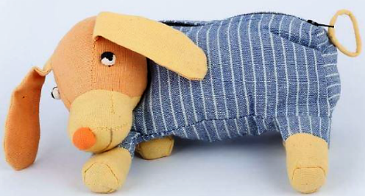

Opening hours

Mon-Thurs 10-17.30
Fri 10-18
Sat 10-16

Fair Trade Bazaren is a social economy store with a mission to trade Fair Trade-certified goods.

The shop is run on non-profit basis of an association. Membership costs 200 DKK. The association was established in 1993 by U-Landsforeningen Svalerne in Aar-hus, which has been running Fair Trade since 1975.

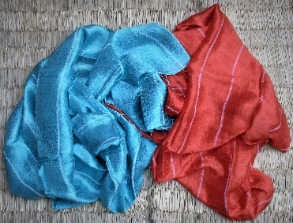

Opening hours

Mon-Thurs 10-17.30
Fri 10-18
Sat 10-16

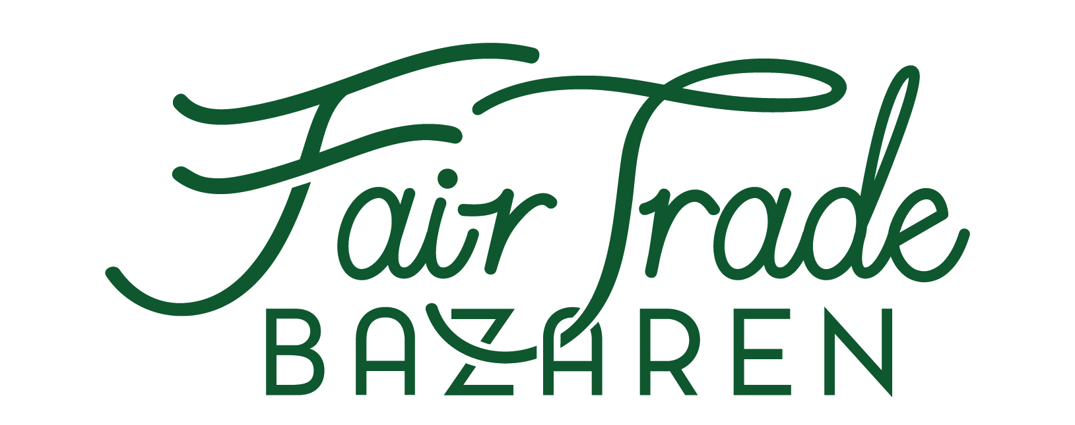

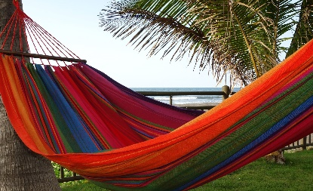
www.fairtradebazaren.dk
Guldsmedgade 8a
8000 Aarhus C
Tlf. 86185111
bazaren@fairbutik.dk

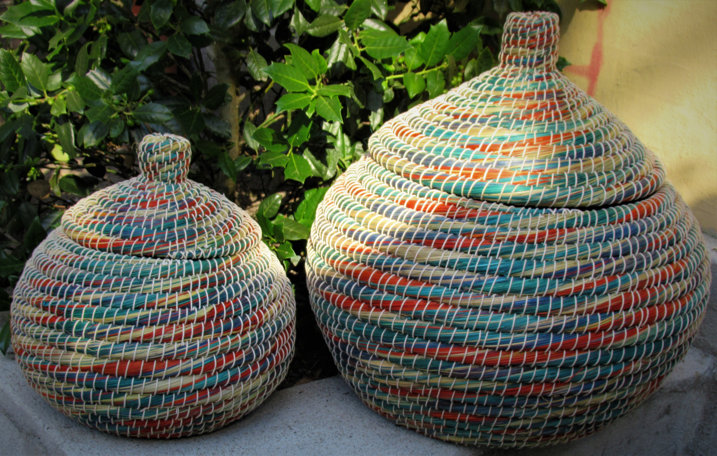
www.fairtradebazaren.dk
Guldsmedgade 8a
8000 Aarhus C
Tlf. 86185111
bazaren@fairbutik.dk

Fair Trade Bazaren is a social economy store with a mission to trade Fair Trade-certified goods.

The shop is run on non-profit basis of an association. Membership costs 200 DKK. The association was established in 1993 by U-Landsforeningen Svalerne in Aarhus, which has been running Fair Trade since 1975.

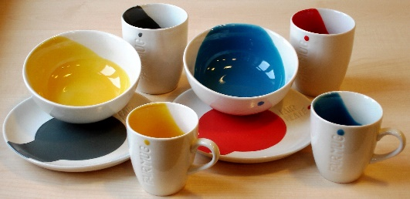

Opening hours

Mon-Thurs 10-17.30
Fri 10-18
Sat 10-16

Fair Trade Bazaren is a social economy store with a mission to trade Fair Trade-certified goods.

The shop is run on non-profit basis of an association. Membership costs 200 DKK. The association was established in 1993 by U-Landsforeningen Svalerne in Aarhus, which has been running Fair Trade since 1975.

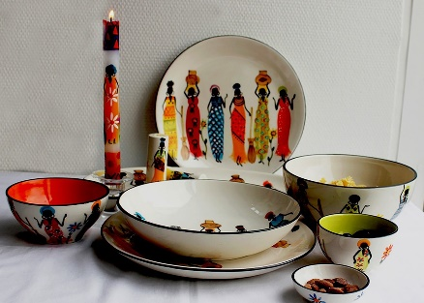

Opening hours

Mon-Thurs 10-17.30
Fri 10-18
Sat 10-16

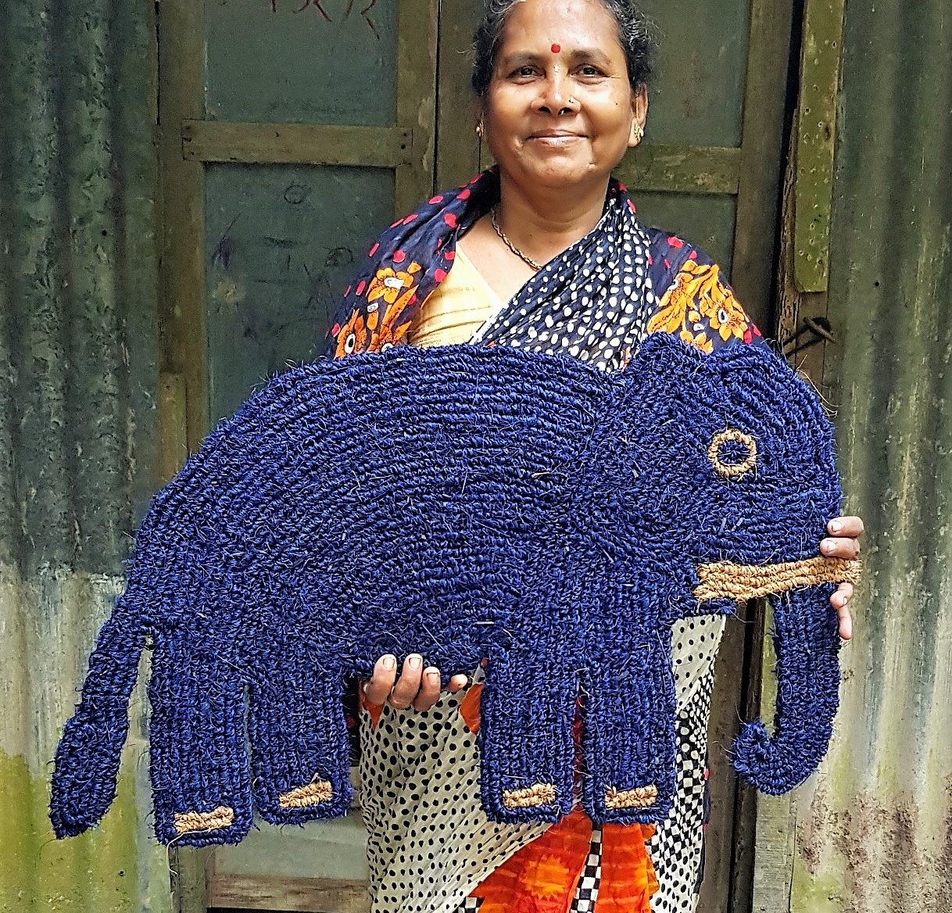
www.fairtradebazaren.dk
Guldsmedgade 8a
8000 Aarhus C
Tlf. 86185111
bazaren@fairbutik.dk

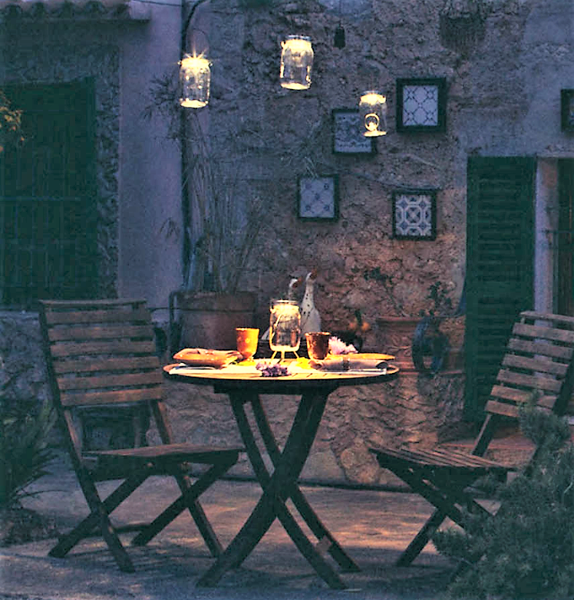
www.fairtradebazaren.dk
Guldsmedgade 8a
8000 Aarhus C
Tlf. 86185111
bazaren@fairbutik.dk

The articles of the shop are produced by artisans and peasants who are Fair Trade certified by either World Fair Trade Organization (www.wfto.com) or Fairtrade International (www.fairtrade.net). We also have a few non-certified articles which we estimate correspond to the Fair Trade re-quirements.

Fair Trade stands for:
better payment to
marginalized people
participation
equality
no child labor
education
environmentally friendly production
no harmful substances in the articles
stable trade relations
openness and transparency

The articles of the shop are produced by artisans and peasants who are Fair Trade certified by either World Fair Trade Organization (www.wfto.com) or Fairtrade International (www.fairtrade.net). We also have a few non-certified articles which we estimate correspond to the Fair Trade re-quirements.

Fair Trade stands for:
better payment to
marginalized people
participation
equality
no child labor
education
environmentally friendly production
no harmful substances in the articles
stable trade relations
openness and transparency

In the Fair Trade Bazaren you will find Denmark’s largest selection of Fair Trade articles.

We specialize in:
Hammocks and hanging chairs
Basketwork
Door mats made of coconut fiber

We have the most interesting cards in the town, fine ceramics from South Africa, alpaca stockings and other woolen goods, child-safe toy, jewelry from many countries, solar powered lamps, paper made of elephant dung, new age articles, world music, many little things to make you happy together with delicious chocolate and quality coffee.
…. and much more !

GO GREEN – GO FAIR TRADE!

In the Fair Trade Bazaren you will find Denmark’s largest selection of Fair Trade articles.

We specialize in:
Hammocks and hanging chairs
Basketwork
Door mats made of coconut fiber

We have the most interesting cards in the town, fine ceramics from South Africa, alpaca stockings and other woolen goods, child-safe toy, jewelry from many countries, solar powered lamps, paper made of elephant dung, new age articles, world music, many little things to make you happy together with delicious chocolate and quality coffee.
…. and much more !

GO GREEN – GO FAIR TRADE!
The articles of the shop are produced by artisans and peasants who are Fair Trade certified by either World Fair Trade Organization (www.wfto.com) or Fairtrade International (www.fairtrade.net). We also have a few non-certified articles which we estimate correspond to the Fair Trade re-quirements.

Fair Trade stands for:
better payment to
marginalized people
participation
equality
no child labor
education
environmentally friendly production
no harmful substances in the articles
stable trade relations
openness and transparency

The articles of the shop are produced by artisans and peasants who are Fair Trade certified by either World Fair Trade Organization (www.wfto.com) or Fairtrade International (www.fairtrade.net). We also have a few non-certified articles which we estimate correspond to the Fair Trade re-quirements.

Fair Trade stands for:
better payment to
marginalized people
participation
equality
no child labor
education
environmentally friendly production
no harmful substances in the articles
stable trade relations
openness and transparency

In the Fair Trade Bazaren you will find Denmark’s largest selection of Fair Trade articles.

We specialize in:
Hammocks and hanging chairs
Basketwork
Door mats made of coconut fiber

We have the most interesting cards in the town, fine ceramics from South Africa, alpaca stockings and other woolen goods, child-safe toy, jewelry from many countries, solar powered lamps, paper made of elephant dung, new age articles, world music, many little things to make you happy together with delicious chocolate and quality coffee.
…. and much more !

GO GREEN – GO FAIR TRADE!

In the Fair Trade Bazaren you will find Denmark’s largest selection of Fair Trade articles.

We specialize in:
Hammocks and hanging chairs
Basketwork
Door mats made of coconut fiber

We have the most interesting cards in the town, fine ceramics from South Africa, alpaca stockings and other woolen goods, child-safe toy, jewelry from many countries, solar powered lamps, paper made of elephant dung, new age articles, world music, many little things to make you happy together with delicious chocolate and quality coffee.
…. and much more !

GO GREEN – GO FAIR TRADE!

